


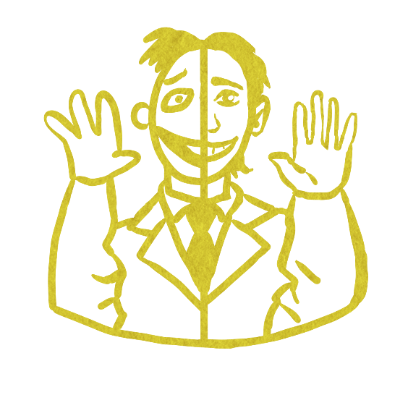

Muppets on a Clocktower
Almanac (2.0)
By Patrick & Josie
By Patrick and Josie#

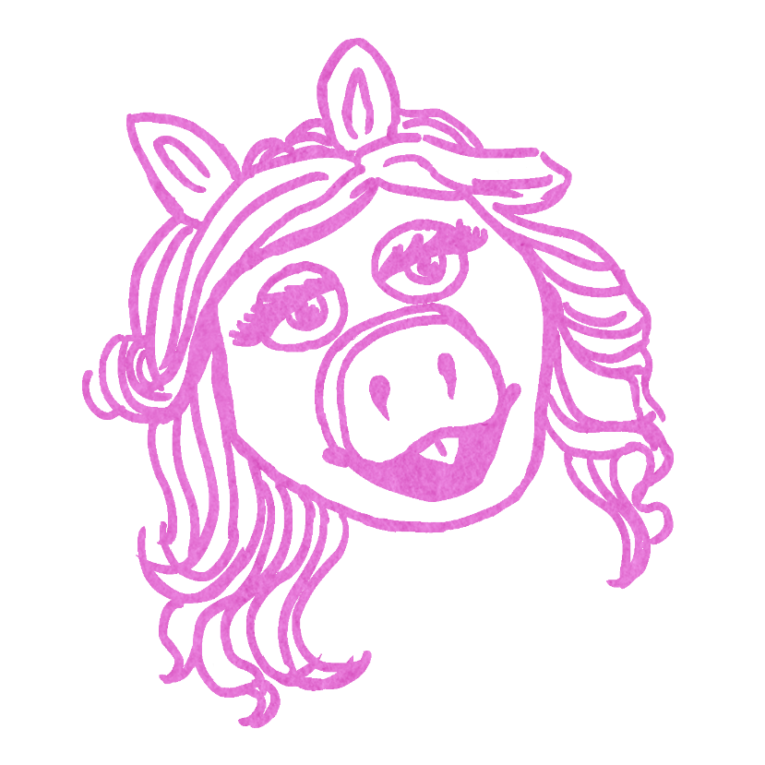
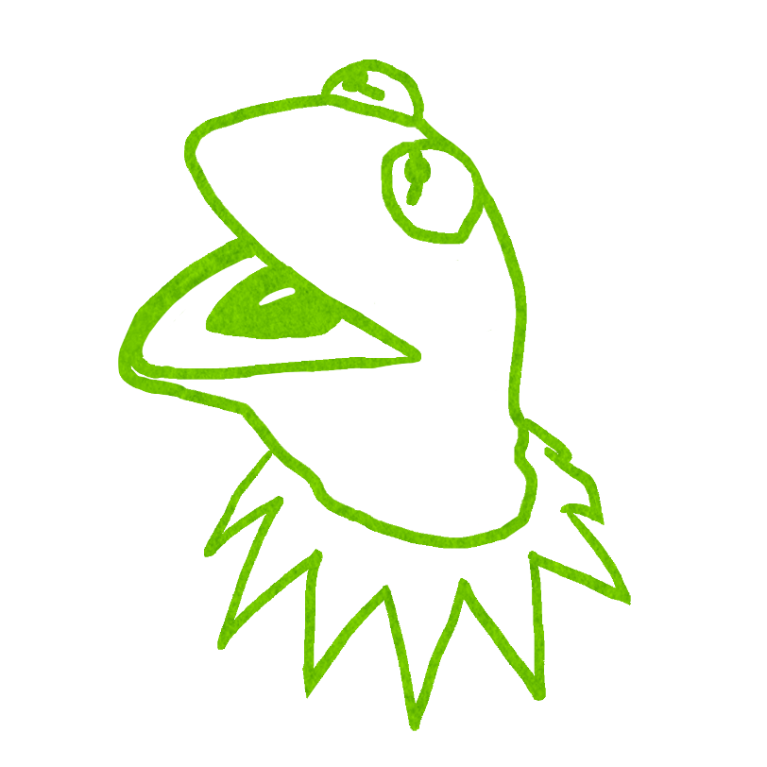

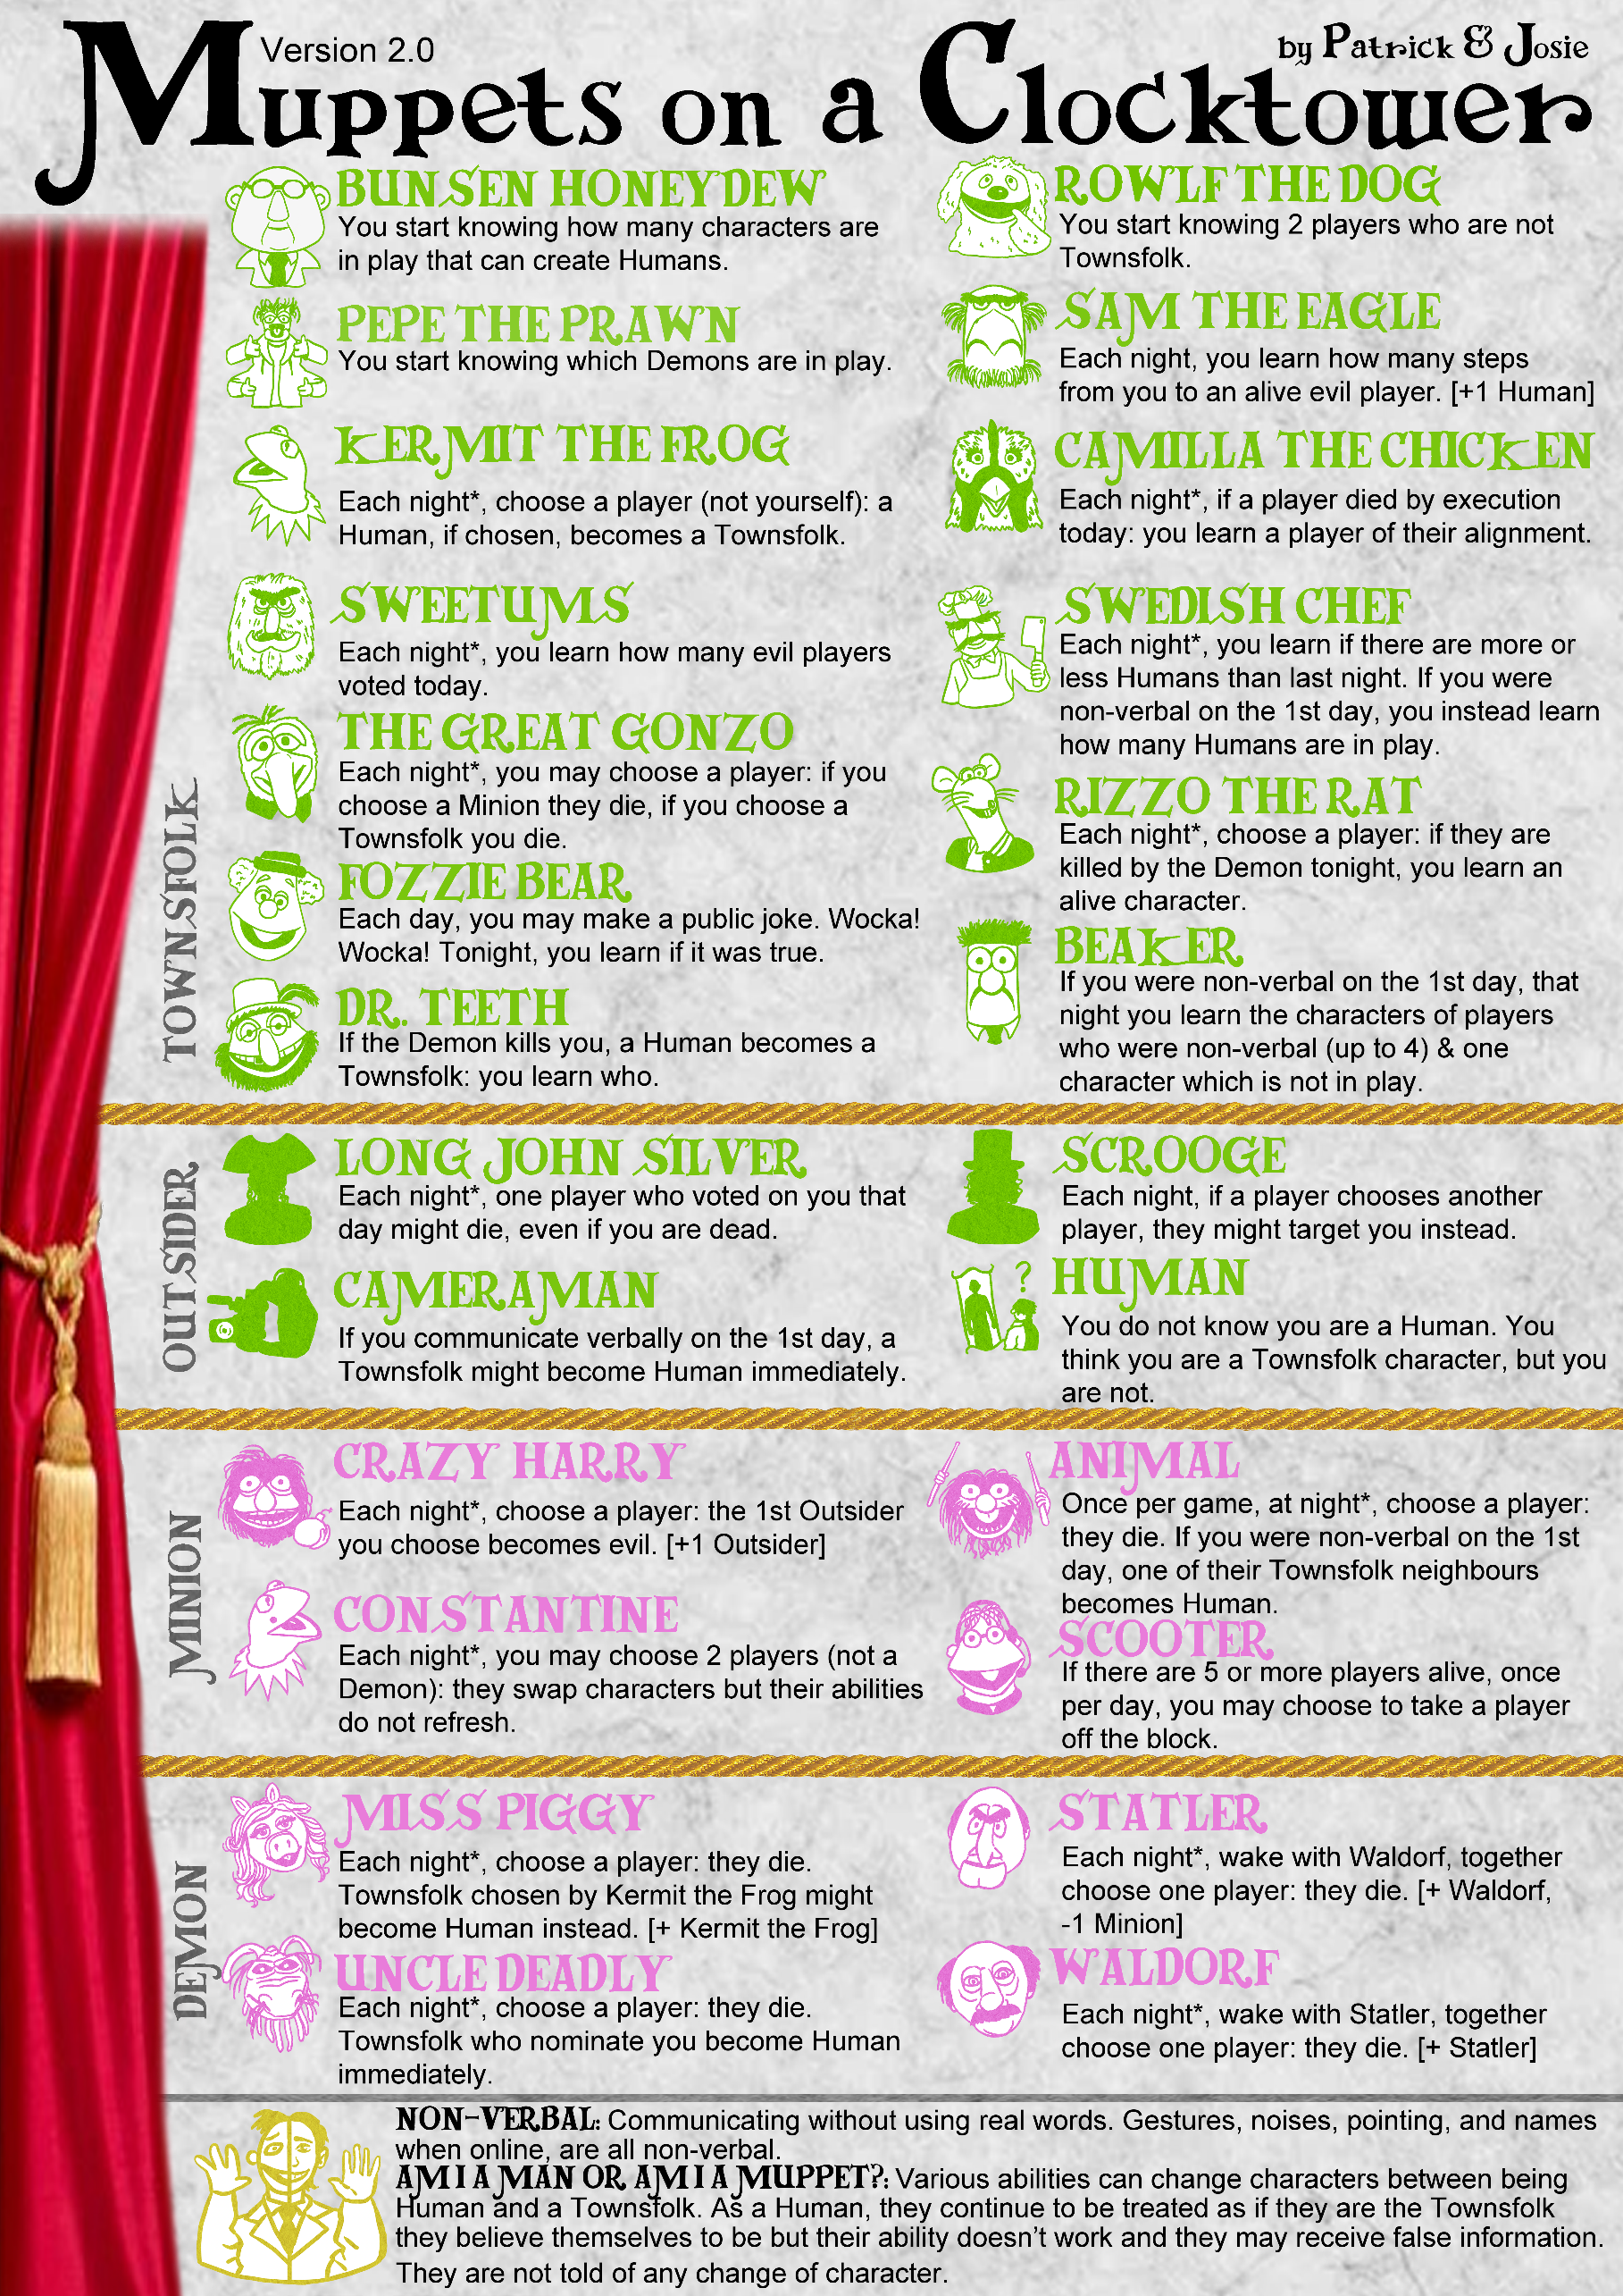

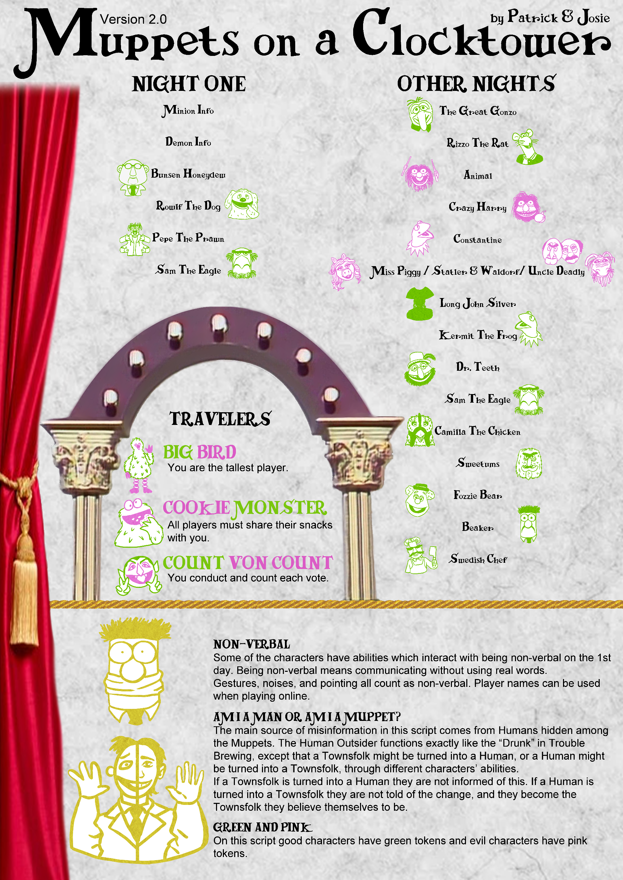



BUNSEN HONEYDEW
TOWNSFOLK
You start knowing how many characters are in play that can create Humans.

“Science has left me a sad and lonely man.”

HOW TO RUN
Count how many of the following characters are in play: Sam the Eagle, Cameraman, Animal, Miss Piggy, Uncle Deadly.
During the first night, wake Bunsen Honeydew. Show Bunsen Honeydew fingers (0, 1, 2, etc.) equalling the number of the above characters that are in play. Put Bunsen Honeydew to sleep.
EXAMPLES
Sam the Eagle is in play and has therefore added a Human into play. On the first night, Bunsen Honeydew learns a 1.
Animal and Uncle Deadly are in play. On the first night, Bunsen Honeydew learns a 2. On the first day, Animal communicates verbally and therefore cannot create Humans. Bunsen Honeydew is not informed that the number of characters that can create Humans has changed.
In a 12-player game the base Outsider count is 2. The Storyteller decides to put the Cameraman and Sam the Eagle tokens in the bag but to make Sam the Eagle the starting Human Outsider. Bunsen Honeydew learns a 1 due to Camerman.

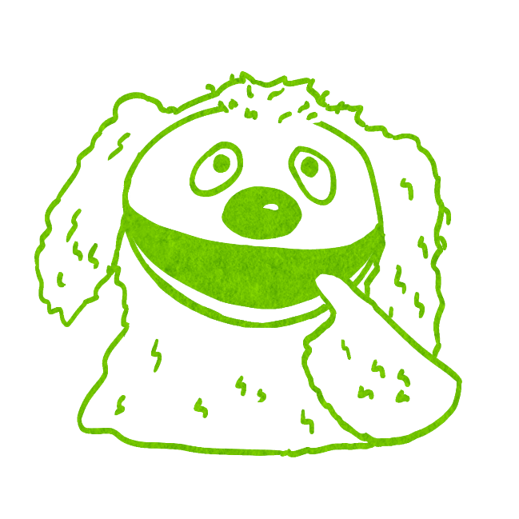

ROWLF THE DOG
TOWNSFOLK
You start knowing 2 players who are not
Townsfolk.

“Why does everyone always blame dogs?”
HOW TO RUN
While preparing the first night, put Rowlf the Dog’s NOT TOWNSFOLK reminder token by any two players that are an Outsider, Minion, or Demon.
During the first night, wake Rowlf the Dog and point to the two players. Put Rowlf the Dog to sleep.
EXAMPLES
John is Long John Silver and Simon is Crazy Harry. Rowlf the Dog learns that John and Simon are not Townsfolk.
Sam thinks he is Fozzie Bear but he is actually Human. On the first night, Rowlf the Dog learns that Sam is not a Townsfolk. On night two, Sam is chosen by Kermit the Frog and is turned into a Townsfolk. Rowlf the Dog does not learn anything more.

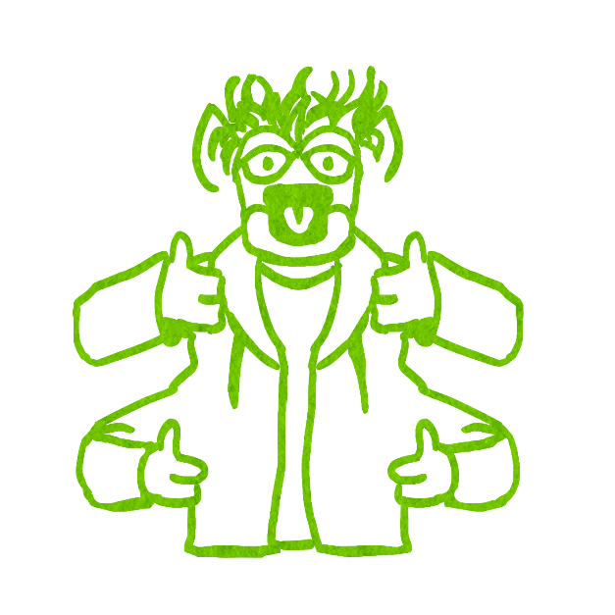

PEPE THE PRAWN
TOWNSFOLK
You start knowing which Demons are in play.

“I am not a shrimp – I am a king prawn, okay!”
HOW TO RUN
During the first night, wake Pepe the Prawn show them the character tokens of the Demons that are in play. Put Pepe the Prawn to sleep.
EXAMPLES
Jake is Miss Piggy. Pepe the Prawn learns that Miss Piggy is in play.
Statler and Waldorf are the Demons in play. On the first night, Pepe the Prawn is shown both tokens.

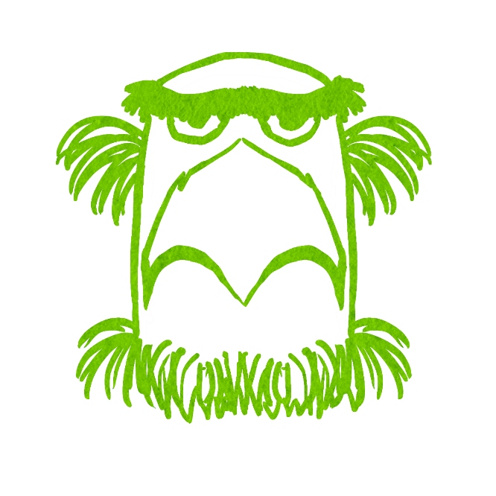

SAM THE EAGLE
TOWNSFOLK
Each night, you learn how many steps
from you to an alive evil player. [+1 Human]

“At times like these, I am proud to be an American.”
HOW TO RUN
While setting up the game, add the normal amount of Townsfolk character tokens to the bag. While preparing the first night, put the HUMAN reminder token by any Townsfolk character token, that player is now a Human. There can be two Humans in play at the start of the game if one is added by Sam the Eagle and one is already in play (due to being added by the base Outsider count).
Each night, wake Sam the Eagle. Show them fingers (0, 1, 2, etc.) equalling the distance from Sam the Eagle to an alive evil player. Put Sam the Eagle to sleep.
The evil player shown does not have to be the same as the previous night. The number of steps does not need to be the shortest, nor does it need to be counted in a particular direction.
EXAMPLES
Sam the Eagle learns a 5 as Constantine is sat 5 seats away. The next day Constantine is executed and dies. The following night, Sam the Eagle must learn a new number as Constantine is no longer alive and the other player sat 5 seats away is good. Sam the Eagle learns a 1 as their neighbour is Uncle Deadly.
Clockwise sitting next to Sam the Eagle is Crazy Harry and anti-clockwise is a Townsfolk. On the first night Sam the Eagle learns a 1. During the day, Sam the Eagle’s Townsfolk neighbour is executed and dies. That night, Sam the Eagle learns a 3 which corresponds to a different evil player sat 3 seats away from him.
It is a 10-player game. Clockwise from Sam the Eagle sits Rowlf the Dog and then Statler. On the first night Sam the Eagle learns a 2, corresponding to Statler. On night 3 Sam the Eagle learns an 8, still corresponding to Statler but this time counted anti-clockwise.

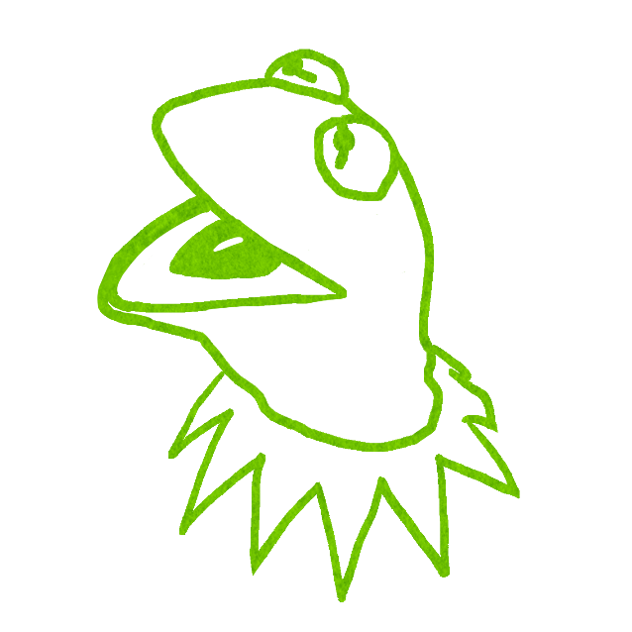

“It's nice to be important, but it's important to be nice.”
KERMIT THE FROG
TOWNSFOLK
Each night*, choose a player (not yourself): a Human, if chosen, becomes a Townsfolk.

HOW TO RUN
Each night except the first, wake Kermit the Frog. Prompt Kermit the Frog to point at any player (if they point at themselves, shake your head no and prompt them to point at another player). Put Kermit the Frog to sleep.
If a Human was chosen, remove the HUMAN reminder token: the chosen player is now the Townsfolk they believe they are. Kermit the Frog, and the player that changes, do not learn this.
If a non-Human is chosen, nothing happens.
If Miss Piggy is in play, place Miss Piggy’s CORRUPTED token next to Kermit the Frog.
Townsfolk chosen by Kermit the Frog might turn into a Human, it is the Storyteller’s choice, but Humans chosen by Kermit the Frog must still turn into Townsfolk.
As this corruption is an evil ability, generally Storytellers should help the evil team with this.
EXAMPLES
On night two, Kermit the Frog selects Jim. Jim was a Human who thought they were Sweetums, and so Jim becomes Sweetums and therefore learns correct information later that night. Neither Jim nor Kermit the Frog are told of this change.
Kermit the Frog selects a player who is a Townsfolk. Miss Piggy is in play, so the Storyteller decides to turn the selected player into a Human.
Kermit the Frog selects a Human while Miss Piggy is in play. That player is turned into the Townsfolk they believed themselves to be.

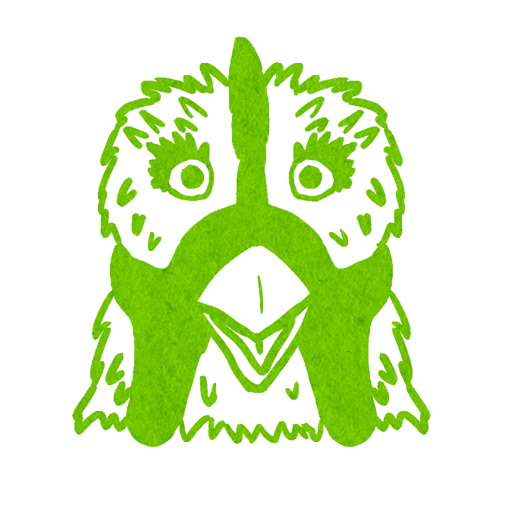

“BAWK BAWK BAWK! BAWK BAWK.”
CAMILLA THE CHICKEN
TOWNSFOLK
Each night*, if a player died by execution
today: you learn a player of their alignment.

HOW TO RUN
If a player dies by execution, put Camilla the Chicken’s EXECUTED TODAY reminder token by the executed player's character token.
Each night except the first, if a player died by execution, wake Camilla the Chicken that night. Point at a player who is the same alignment as the player marked EXECUTED TODAY. Put Camilla the Chicken to sleep. Remove the reminder token when convenient.
EXAMPLES
It is the third night and Animal was executed today. Camilla the Chicken is pointed at Jasmine, who is an evil Minion Scooter.
Bunsen Honeydew, a good character, is executed and dies. That night, Camilla the Chicken is woken and Edward is pointed at. Edward is Constantine, whose ability can make them register as good.
On the second day, the vote ties and no one is executed. Camilla the Chicken does not wake that night.
The evil Outsider Scrooge is executed. There is only one living evil player, so the Storyteller decides to point to the evil Minion Animal who is already dead.

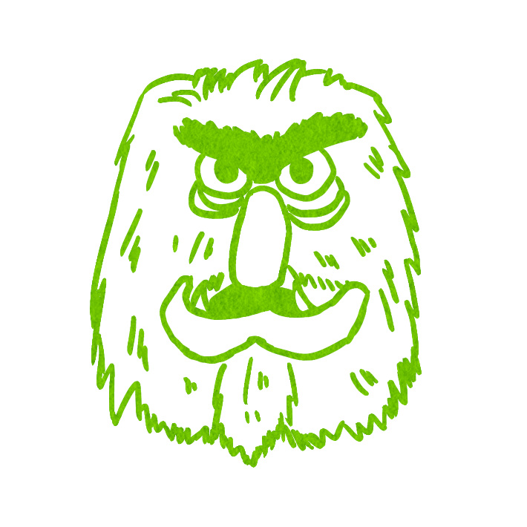

HOW TO RUN
Each day, if an evil player votes for any execution, place an EVIL VOTED reminder token next to them. If they vote on multiple executions, it still only counts as one.
Each night except the first, count the number of EVIL VOTED reminder tokens and then wake Sweetums. Show them fingers (0, 1, 2, etc.) equalling the number of evil players who voted. Then, put Sweetums to sleep.
Each dawn, remove all EVIL VOTED reminder tokens from the Grimoire.
If you forget whether an evil player voted or not, wake them at night and ask by showing them the DID YOU VOTE TODAY? info card. They must answer honestly, then go to sleep.
EXAMPLES
There was one nomination today. Lots of players voted, including the evil Minion Crazy Harry and the evil Outsider Cameraman. That night, Sweetums learns a 2.
There were 3 nominations today. The Minion Constantine voted during the second nomination. No other evil players voted. Nobody was executed. That night, Sweetums learns a 0 as Constantine registers as good due to their ability.
There were no nominations today. A Traveller was exiled, and all players raised their hand to support the exile. That night, Sweetums learns a 0. (Exiles are never affected by abilities).

“Excuse me Mr. Price, can I give you a hand? (takes off hand)”
SWEETUMS
TOWNSFOLK
Each night*, you learn how many evil players voted today.
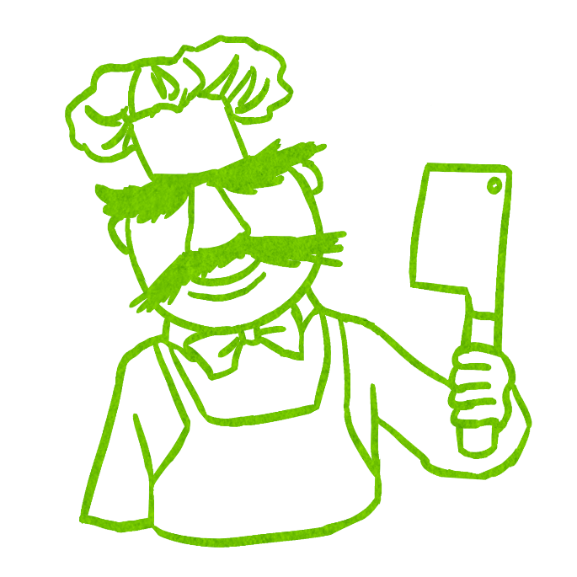

HOW TO RUN
On the first day, observe if Swedish Chef is non-verbal and place the NON-VERBAL reminder token next to them if they were.
Each night except the first, look to see if there has been a change in the number of Humans in play. Wake Swedish Chef and give a thumbs up if there are more Humans, a thumbs down if there are less Humans, and a thumb to the side if there has been no change.
If the NON-VERBAL reminder token is next to them, instead wake Swedish Chef and show them fingers (0, 1, 2, etc.) equalling the number of Humans in play. Put Swedish Chef to sleep.
If you forget whether they were non-verbal or not, wake them at night and ask by showing them the NON-VERBAL fabled token. They must answer honestly, then go to sleep.
EXAMPLES
On the first day, Swedish Chef spoke exclusively in weird noises and was marked with the NON-VERBAL reminder token. That night, Swedish Chef was woken and shown a 0 as there are no Humans in play.
At the start of the game there is 1 Human in play due to the Outsider count. On the first day Swedish Chef communicated verbally. Uncle Deadly was nominated by a Townsfolk, which turned them into a Human. There is one more Human in play than previously, so that night Swedish Chef is woken and shown a thumbs up.
On night two, Kermit the Frog chose the only Human and turned them into a Townsfolk. Later that night, Swedish Chef was woken and shown either a 0 if they are marked with the NON-VERBAL reminder token, or a thumbs down if they communicated verbally on day 1.

SWEDISH CHEF
TOWNSFOLK
Each night*, you learn if there are more or less Humans than last night. If you were non-verbal on the 1st day, you instead learn how many Humans are in play.
“Herdy dur shur floompty. Bort, bort, bort!”
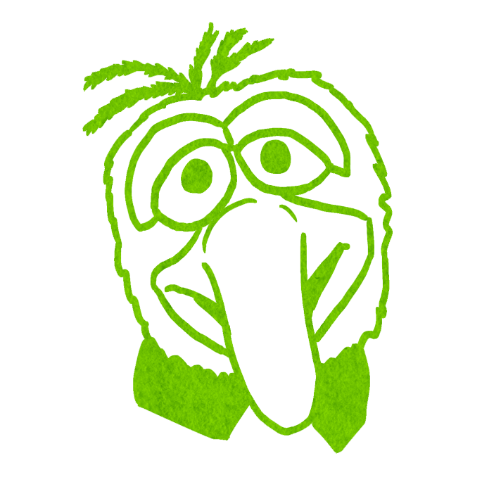

HOW TO RUN
Each night except the first, wake The Great Gonzo. They either shake their head no or point at any player. Put The Great Gonzo to sleep.
If they shake their head no, nothing happens.
If The Great Gonzo chose a player, check the chosen player’s character type. If a Minion was chosen that player dies: mark them with the DIED TONIGHT reminder token. If a Townsfolk was chosen The Great Gonzo dies: mark them with the DIED TONIGHT reminder token.
If an Outsider or a Demon was chosen, nothing happens.
EXAMPLES
On the second night, The Great Gonzo wakes but chooses not to act. On the third night, they choose Scooter. Scooter is a Minion so Scooter dies in the night.
On the second night, The Great Gonzo points to a Townsfolk. The Great Gonzo dies.
The Great Gonzo chooses Animal. The Storyteller decides to use Scrooge’s ability to make The Great Gonzo target Scrooge instead. Scrooge is an Outsider and so nothing happens.

“Tonight ladies and gentlemen, I will eat this rubber tire to the music of The Flight of the Bumblebee...music, maestro!"
THE GREAT GONZO
TOWNSFOLK
Each night*, you may choose a player: if you choose a Minion they die, if you choose a Townsfolk you die.
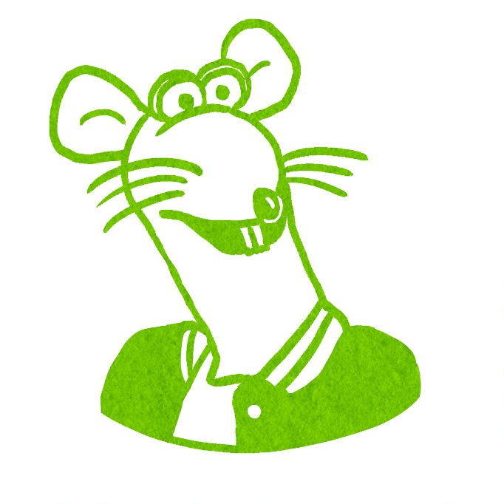

HOW TO RUN
Each night except the first, wake Rizzo the Rat. Rizzo the Rat points at any player. Put Rizzo the Rat to sleep. Put Rizzo the Rat’s CHOSEN reminder token by the chosen player's character token.
If the chosen player is killed by the Demon tonight, wake Rizzo the Rat and show them an alive in-play character token. If the chosen player is not killed in the night, or dies to another ability, Rizzo the Rat is not woken.
At dawn, remove the CHOSEN reminder token.
EXAMPLES
On the second night, Rizzo the Rat chose Sarah who is playing Beaker. Later that night, Sarah is chosen by the Demon and dies. Rizzo the Rat is then woken and shown the Kermit the Frog token, because that character is alive and in play.
Rizzo the Rat selects The Great Gonzo. The Great Gonzo uses their ability and selects a Townsfolk. They die due to their own ability and so Rizzo the Rat is not woken.

“He died?! And this is supposed to be a kids movie!”
RIZZO THE RAT
TOWNSFOLK
Each night*, choose a player: if they are killed by the Demon tonight, you learn an alive character.
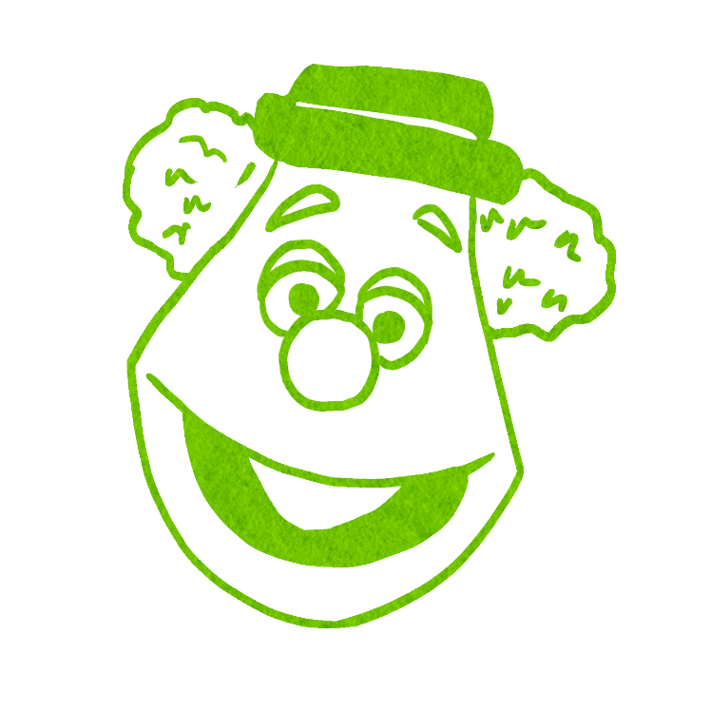

HOW TO RUN
Each day, Fozzie Bear may make a public statement about the game in the form of a joke. These jokes do not have to be good, funny, nor verbal but should end with Fozzie Bear’s classic catchphrase “Wocka! Wocka!”. If Fozzie Bear’s statement is true, place the TRUE reminder token next to their character token.
Each night except the first, if Fozzie Bear made a public joke today, wake them and either nod your head if their joke was true, or shake your head if their joke was false.
Storytellers should interpret the joke to the best of their ability, but provide no clarification on how they understood the joke during the game.
If players are bluffing as Fozzie Bear, it is helpful to stand by the Grimoire and pretend to move tokens and listen to their jokes.
EXAMPLES
During the day, Fozzie Bear jokes “Did you hear the one about how Janet is the Demon? Wocka Wocka!” Janet is the Demon. Despite no one laughing, Fozzie Bear is still woken up and told that their joke was true.
On the first day, Fozzie Bear is attempting to be non-verbal. Fozzie Bear raises their hand, points at two players, gives a thumbs down with an angry face, and then says “Wocka Wocka!”. The Storyteller interprets that Fozzie Bear is joking that both players are evil. That night, The Storyteller wakes Fozzie Bear and shakes their, as both players are good.
During the day, Fozzie Bear jokes “What do Ned and Katie have in common? They’re on the same team! Wocka Wocka!”. That night Ned, who is Long John Silver, is selected by Crazy Harry and turns evil. However, at the time of the joke, both Ned and Katie were good so Fozzie Bear still learns that their joke was true.

“Did I tell you the one about the man with the light bulb in his nose? He was lightheaded! Get it? Wocka Wocka!”
FOZZIE BEAR
TOWNSFOLK
Each day, you may make a public joke. Wocka! Wocka! Tonight, you learn if it was true.


“Meep meep meep!”
BEAKER
TOWNSFOLK
If you were non-verbal on the 1st day, that night you learn the characters of players who were non-verbal (up to 4) & one character which is not in play.
HOW TO RUN
On the first day, observe if Beaker is non-verbal and place Beaker’s NON-VERBAL reminder token next to them if they were. Also look to see who else is being non-verbal and mark them with the same reminder tokens.
The second night, if Beaker was non-verbal, select up to 4 players who were also non-verbal. Wake Beaker and show them the chosen players’ character tokens and one not-in-play character token. Put Beaker to sleep. If Beaker communicated verbally then they do not wake.
If you forget who was non-verbal or not, wake them at night and ask by showing them the NON-VERBAL fabled token. They must answer honestly, then go to sleep.
EXAMPLES
During the first day, Beaker communicated exclusively in meeps and so was successful in being non-verbal. Dr. Teeth, Cameraman, Animal, Statler, Pepe the Prawn, and a Human were also non-verbal. That night, Beaker is shown Dr. Teeth, Cameraman, Animal, Human, and one of the Demon’s bluffs: Sweetums.
During the first day there are 3 players that are non-verbal; Beaker, a Human who believes they are Kermit the Frog, and Swedish Chef. That night, Beaker is shown Beaker, Swedish Chef, and Kermit the Frog.
During the first day, Beaker accidently answers verbally when asked a question. That night they learn nothing.



HOW TO RUN
If Dr. Teeth was killed by the Demon in the night, choose a player that is a Human and turn them into the Townsfolk they thought they were. Wake Dr. Teeth and point at the changed player. If there are no Humans in play, instead wake Dr. Teeth and shake your head no. Put Dr. Teeth to sleep.
EXAMPLES
Durning the night, the Demon selects to kill Dr.Teeth. Mark is a Human who received the Fozzie Bear token, so they are turned into Fozzie Bear. Dr. Teeth is woken and pointed to Mark.
During the night, Animal selects Dr. Teeth, which means that Dr. Teeth dies. Dr. Teeth was not killed by the Demon and therefore nothing happens.
Durning the night, the Demon kills Dr. Teeth. There are no Humans in play. Dr. Teeth is woken and told no.

“This staccato tune is posolutely, most transparently bringing me down!”
DR. TEETH
TOWNSFOLK
If the Demon kills you, a Human becomes a Townsfolk: you learn who.
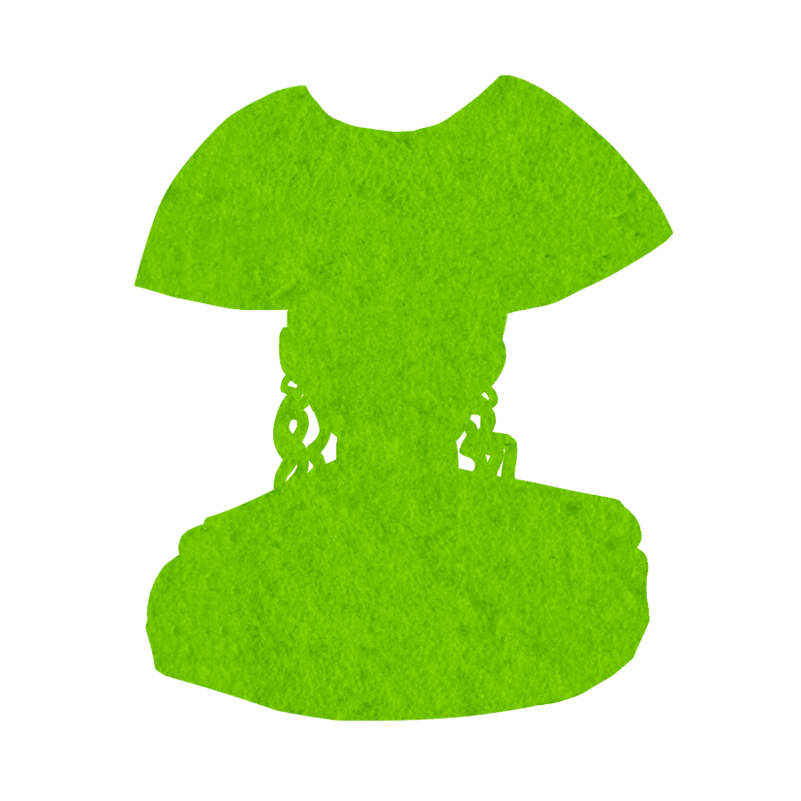

HOW TO RUN
Each day, if Long John Silver is nominated, mark anyone who votes on them with one of Long John Silver’s VOTED reminder tokens. That night, you may kill one of the people who voted by placing Long John Silver’s DIED TONIGHT reminder token next to their character token.
EXAMPLES
There are 2 nominations on day 1. Long John Silver is the second nomination. Beaker, Fozzie Bear, and Animal vote on them. Beaker dies that night.
Durning the day, Long John Silver is nominated and a majority of players vote to kill them. Long John Silver is executed and dies. The Storyteller choses to kill one of the players who voted on Long John Silver’s execution.
There are 4 players alive. A Minion nominates the dead Long John Silver and is the only vote. That night, the Demon kills a player and so the Storyteller decides not to kill the Minion because it would end the game.

“Upstage, lads. This is my only number!”
LONG JOHN SILVER
OUTSIDER
Each night*, one player who voted on you that day might die, even if you are dead.


HOW TO RUN
During the night, whenever a player targets another player with their ability, you can instead choose for them to target Scrooge. You can use the SCROOGED reminder token to indicate that they targeted Scrooge instead. Do not tell the affected player that they have instead targeted Scrooge.
Characters that target others include: Kermit the Frog, The Great Gonzo, Rizzo the Rat, Crazy Harry, Constantine, Animal, and all the Demons.
EXAMPLES
In the night, the Demon chooses to kill Dr. Teeth. The Storyteller choses for it to target Scrooge instead, and so Scrooge dies.
At night, The Great Gonzo chooses a Minion, which would kill the Minion. Instead, they target Scrooge, an Outsider, so their The Great Gonzo’s ability does nothing.
At night, the Demon kills Scrooge. Rizzo the Rat originally chose a different player but the Storyteller decides that Rizzo the Rat targets Scrooge instead. Because Scrooge was chosen by Rizzo the Rat, and Scrooge was killed by the Demon, Rizzo the Rat learns an alive character.

“Who was the wretched man whose death brought so much glee and happiness to others?”
SCROOGE
OUTSIDER
Each night, if a player chooses another player, they might target you instead.


HOW TO RUN
On the first day, observe if Camerman is non-verbal or not. If they communicate verbally, you can immediately make one Townsfolk a Human.
If you forget if they were non-verbal or not, wake them at night and ask by showing them the NON-VERBAL fabled token. They must answer honestly, then go to sleep.
EXAMPLES
During the first day, Camerman accidently answers verbally when asked a question. The Storyteller decides to immediately turn Fozzie Bear into a Human. The Camerman is executed and dies. The Human remains in play.
During the first day, Cameraman communicates only in weird noises and gestures and is therefore non-verbal. Nothing happens.
During the first day, the Cameraman speaks verbally. The Storyteller decides not to create a Human.

“…”
CAMERAMAN
OUTSIDER
If you communicate verbally on the 1st day, a Townsfolk might become Human immediately.
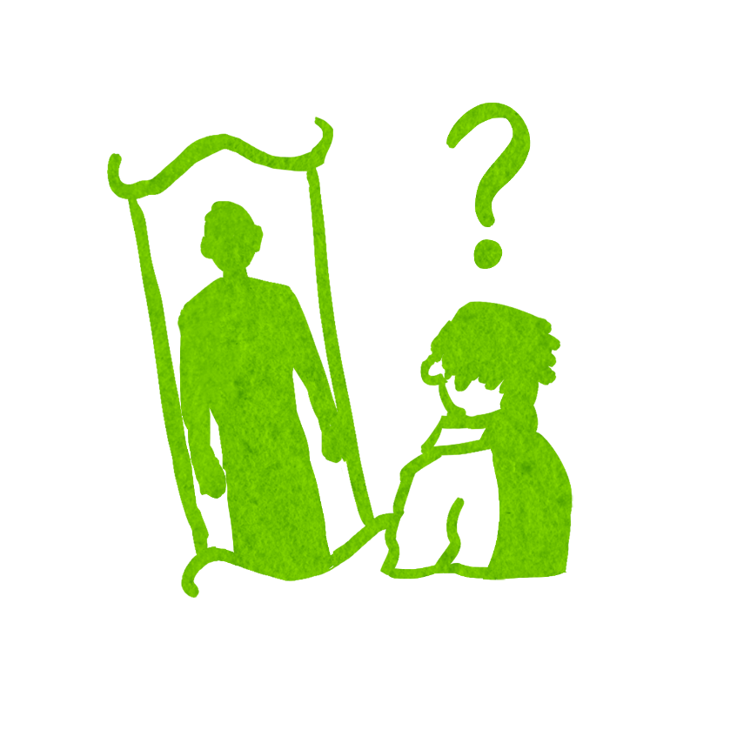

HOW TO RUN
While setting up the game, before putting character tokens in the bag, remove the Human token and add a Townsfolk character token. Add the Human's HUMAN reminder token to the Grimoire. Put the swapped Townsfolk character token in the bag, not the Human character token.
While preparing the first night, put the Human's HUMAN reminder token by any Townsfolk character token, changing that player's character to a Human. They are now an Outsider, and do not have the ability of this Townsfolk character. (But they think they do.)
During the game, act as if the Human is actually this Townsfolk character. (If that character would wake to act at night, the Human wakes to act. If their ability would give them information, you can give false information to them if you wish.)
If a Townsfolk is turned into a Human they are not told of the change. If a Human is turned into a Townsfolk they are not told, and they become the Townsfolk they believe themselves to be.
EXAMPLES
The Demon is Miss Piggy. A Human, who thinks they are Pepe the Prawn, learns that Uncle Deadly is in play.
A Human, who thinks they are The Great Gonzo, chooses a Minion. Nothing happens.
A Human, who thinks they are Fozzie Bear, is chosen by Kermit the Frog. They become Fozzie Bear and do not learn of this change.

“Am I a man? Or am I a Muppet?”
HUMAN
OUTSIDER
You do not know you are a Human. You think you are a Townsfolk character, but you are not.
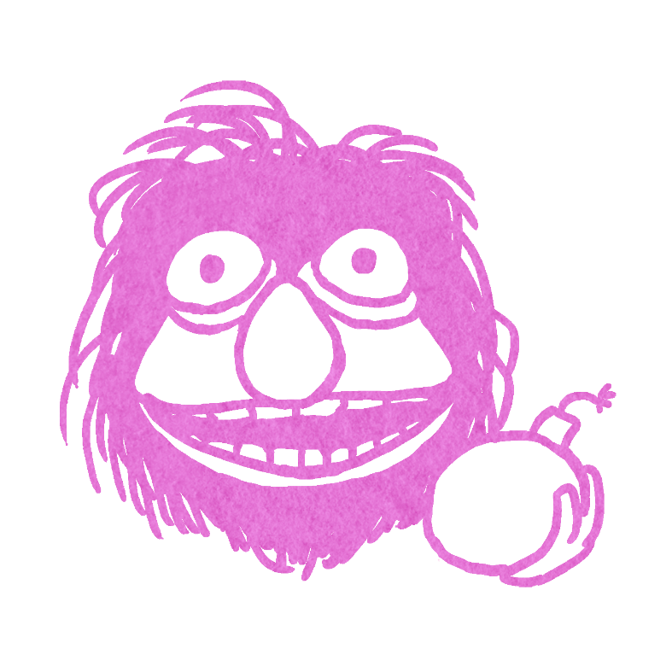

HOW TO RUN
While setting up the game, before putting character tokens in the bag, add one extra Outsider character token and remove one Townsfolk character token.
Each night except the first, wake Crazy Harry. Crazy Harry points at any player. Put Crazy Harry to sleep.
If Crazy Harry chose an Outsider mark them with the TURNS EVIL reminder token, and wake the Outsider to inform them of their alignment change by showing them the YOU ARE info token then giving a thumbs down. Turn their character token upside down. (This shows they are now evil.)
If Crazy Harry chooses a player that is not an Outsider nothing happens.
Continue to wake Crazy Harry on subsequent nights even after they turn an Outsider evil, but do not turn anymore Outsiders evil.
EXAMPLES
On the second night, Crazy Harry chooses a Human who turns evil. On the third night, Crazy Harry chooses Cameraman but, because an Outsider has already turned evil, nothing happens.
For multiple nights Crazy Harry has only chosen Townsfolk. The Storyteller choses to use Scrooge’s ability to make Crazy Harry target Scrooge. Scrooge now turns evil.
Helen is playing Long John Silver and Tom is Sam the Eagle. One night, Crazy Harry chooses Helen, turning them evil. Later that same night, Constantine swaps Helen and Tom. Helen is now an evil Sam the Eagle and Tom is a good Long John Silver.

“Heh, heh—Did somebody say… BOMB !?”
CRAZY HARRY
MINION
Each night*, choose a player: the 1st Outsider you choose becomes evil. [+1 Outsider]
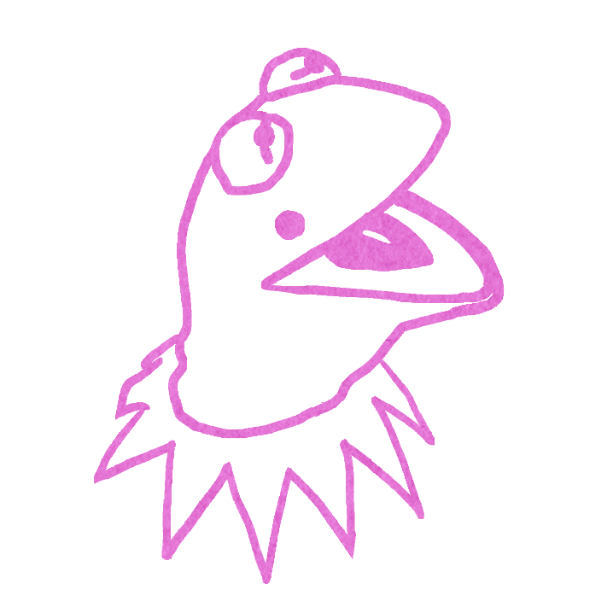

HOW TO RUN
Each night except the first, wake Constantine. Constantine either shakes their head no, or points to two players, neither of which can be the Demon. (If Constantine points at a Demon, shake your head no and prompt them to point at another player.) Put Constantine to sleep.
If Constantine pointed to two players, swap the character tokens of the chosen players. One at a time, wake each swapped player, show them the YOU ARE info token and their new character token, then put them to sleep. If a player’s alignment does not match the colour of their character token, turn it upside-down. You may wish to remind them that their alignment has not changed.
If characters are swapped note that no abilities are refreshed. This means once per game abilities can not be used again, and first night characters do not learn new information.
Each time Constantine is targeted by an ability that detects or affects good characters, choose what alignment Constantine registers as. (Do whatever is appropriate, such as showing a Kermit the Frog token, nodding, giving finger signals, or allowing an ability to work that would normally only affect a good Townsfolk).
EXAMPLES
Constantine chooses to swap Fred, who is Pepe the Prawn, and Velma, who is Swedish Chef. Velma is now Pepe the Prawn and does not learn any information. Fred is now playing Swedish Chef. Fred was not non-verbal on the first day and so is woken later that night to learn that there are fewer Humans in play.
Constantine chooses to swap the alive Camerman with the dead Animal that already used their ability. Now, there is an alive good Animal with no ability and a dead evil Camerman with no ability.
Constatine is chosen by The Great Gonzo. Instead of killing Constanine, the Storyteller chooses to register Constantine as Kermit the Frog. This means they register as a Townsfolk and The Great Gonzo dies.

“My name will go down as the greatest thief of all time!”
CONSTANTINE
MINION
Each night*, you may choose 2 players (not a Demon): they swap characters but their abilities do not refresh.
You might register as good, and as Kermit the Frog, even if dead.

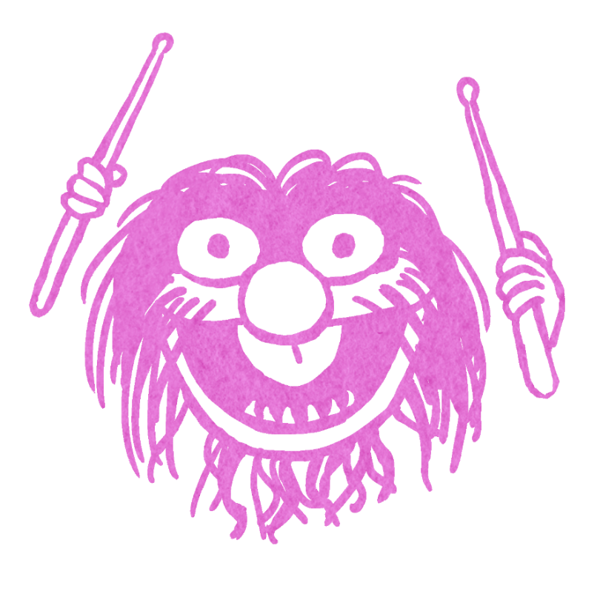

HOW TO RUN
On the first day, observe if Animal is non-verbal and place the NON-VERBAL reminder token next to them if they were.
Each night except the first, wake Animal. They either shake their head no or point at any player. Put Animal to sleep.
If Animal chose a player, that player dies: mark them with the DIED TONIGHT reminder token. If Animal was non-verbal on the first day, choose one of the chosen player’s Townsfolk neighbours to become a Human. Animal loses their ability—mark them with the NO ABILITY reminder token and remove their night token from the night sheet. (Animal won’t wake again.)
If you forget whether they were non-verbal or not, wake them at night and ask by showing them the NON-VERBAL fabled token. They must answer honestly, then go to sleep.
EXAMPLES
- On the first day, Animal communicated only in gestures and was non-verbal. That night, Animal chooses to kill Sam the Eagle, who dies. Sam the Eagle neighbours Scooter then Beaker on one side and Sweetums on the other. The Storyteller chooses to make Beaker a Human.

- On the first day, Animal communicated verbally to their and so their NON-VERBAL reminder token was not placed. On a later night, Animal chooses to kill Dr. Teeth, whose ability therefore doesn’t work. No Townsfolk is turned into a Human.

- Animal is woken on the second night and chooses not to use their ability. On the third day Animal is executed and dies. Constanine swaps themselves and Animal. The now alive Animal can use their ability to kill the following night, however, the new Animal communicated verbally on the first day, so no Human is created.

“BEAT DRUMS! BEAT DRUMS!”
ANIMAL
MINION
Once per game, at night*, choose a player: they die. If you were non-verbal on the 1st day, one of their Townsfolk neighbours becomes Human.
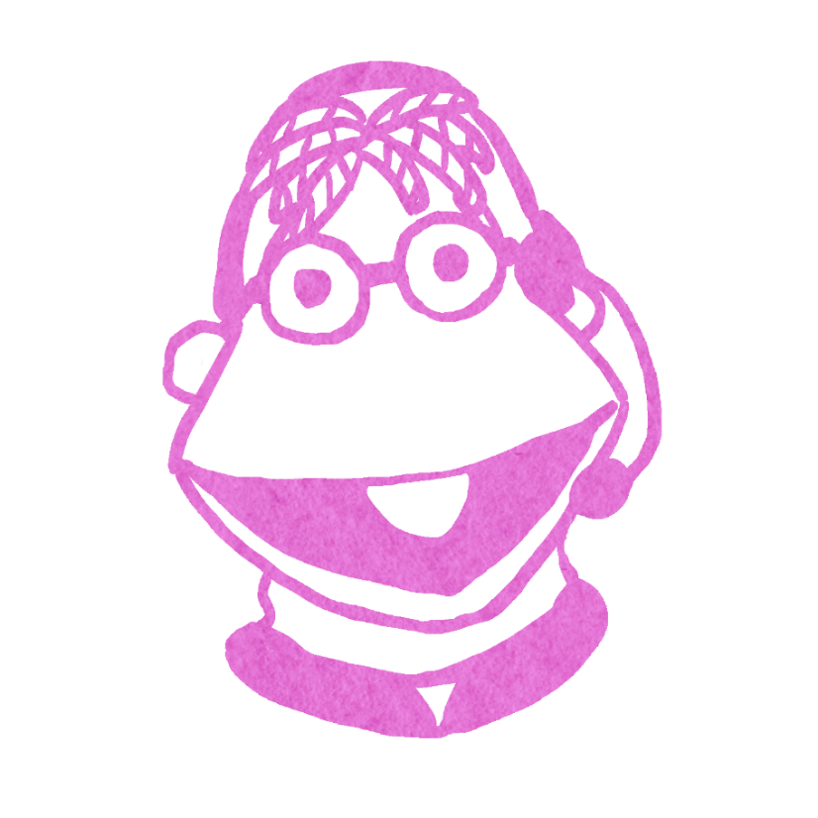

HOW TO RUN
After a nomination has occurred and a player is on the block, Scooter may publicly declare that they wish to use their ability to take the person off the block. Announce that the nominated player is no longer about to die and the nomination process continues as normal. If Scooter takes a player off the block, players that voted on that player can still die due to Long John Silver’s ability.
If a player was previously on the block, they go back to being on the block.
Scooter loses their ability for the day – place Scooter’s USED TODAY reminder token.
At dawn, remove the USED TODAY reminder token.
When less than 5 players live, place the NO ABILITY reminder token as Scooter can no longer take anyone off the block.
EXAMPLES
There are 10 players alive so 5 votes are needed to execute. Beaker was about to die with 5 votes, but Miss Piggy is nominated and is put on the block with 6 votes, so now Miss Piggy is about to die. Scooter uses their ability to take Miss Piggy off the block. So, as before, Beaker is about to die with 5 votes, and the nomination process continues.
There are 6 players alive so 3 votes are needed to execute. Rowlf the Dog is nominated and receives 4 votes, then Sweetums is nominated and receives 3 votes. Scooter says “CUT!” to take Rowlf the Dog off the block. There is no one on the block as Sweetums was not previously on the block. Another play then decides to nominate Scooter and every alive player votes. Scooter cannot save themselves as they have already used their ability today. Scooter is executed and dies.

SCOOTER
MINION
If there are 5 or more players alive, once per day, you may choose to take a player off the block.

“(Holds the clapboard the wrong way) Okay, Muppet Movie, Scenery 1A, Take One!!”
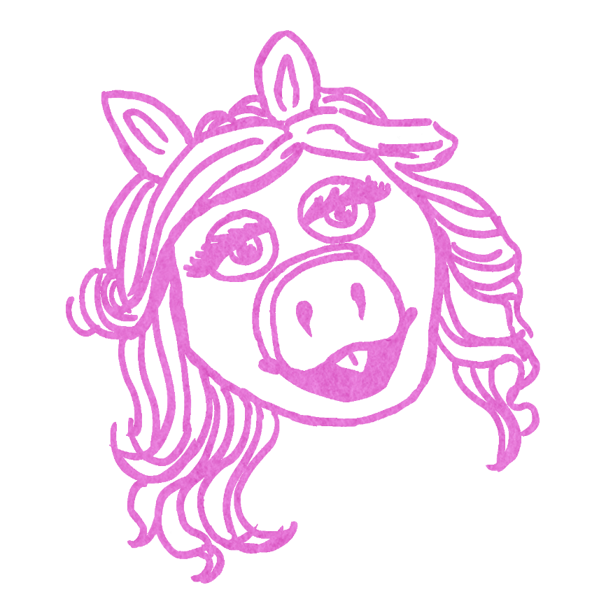

“Women are like bacon, they smell good, they probably taste good, and they will kill you slowly.”
MISS PIGGY
DEMON
Each night*, choose a player: they die. Townsfolk chosen by Kermit the Frog might become Humans instead. [+ Kermit the Frog]
HOW TO RUN
While setting up the game, before putting character tokens in the bag, if Kermit the Frog is not already in play, remove a Townsfolk character token and add the Kermit the Frog character token.
When setting up the Grimoire, remember to put Miss Piggy’s CORRUPTED token next to Kermit the Frog. Kermit the Frog’s ability might now turn Townsfolk chosen into a Human (see the Kermit the Frog entry for more information).
Each night except the first, wake Miss Piggy. Miss Piggy points at any player. Put Miss Piggy to sleep. The chosen player dies: put Miss Piggy's DIED TONIGHT reminder by the chosen player's character token in the Grimoire and put a shroud on it.
At dawn, declare which player(s) died at night. (Do not say how they died.)
EXAMPLES
During the night, Miss Piggy wakes and chooses a player. They player dies.
During the night, Miss Piggy wakes and chooses Dr. Teeth. Dr. Teeth was chosen earlier that night by Animal and so is already dead and their ability doesn’t work. There is only one death that night.
Kermit the Frog selects a player who is a Townsfolk. Miss Piggy is in play so the Storyteller decides to turn the selected player into a Human.

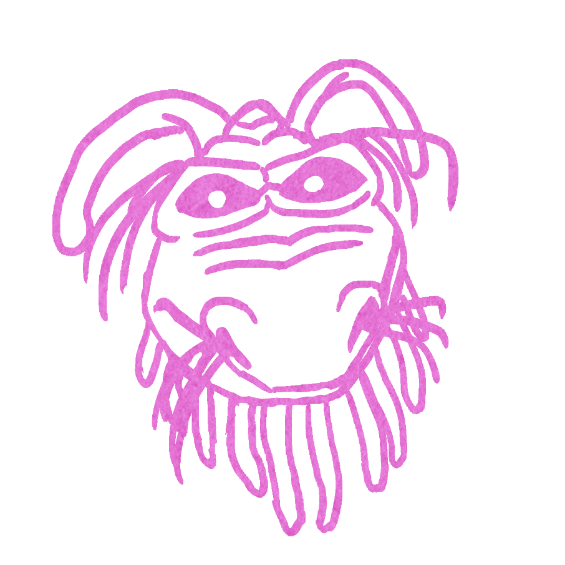

“I swore I would never perform here again, nor would anyone else. I will drive you all from this theatre. LEAVE OR BE DOOOOOOOOOMED!”
UNCLE DEADLY
DEMON
Each night*, choose a player: they die. Townsfolk who nominate you become Human immediately.
HOW TO RUN
Each night except the first, wake Uncle Deadly. Uncle Deadly points at any player. Put Uncle Deadly to sleep. The chosen player dies: put Uncle Deadly's DIED TONIGHT reminder token by the chosen player's character token in the Grimoire and put a shroud on it.
At dawn, declare which player(s) died at night. (Do not say how they died.)
During nominations, if Uncle Deadly is nominated by a Townsfolk, place a HUMAN reminder token. They immediately become a Human.
EXAMPLES
During the night, Uncle Deadly wakes and chooses a player. The chosen player dies.
On the first day Uncle Deadly is nominated by Scrooge. Scrooge is an Outsider and therefore nothing happens.
On the second day Uncle Deadly is nominated by Fozzie Bear who immediately becomes a Human and receives false information about their joke that night. Neither Uncle Deadly or the player that thinks they are Fozzie Bear learn of this change.

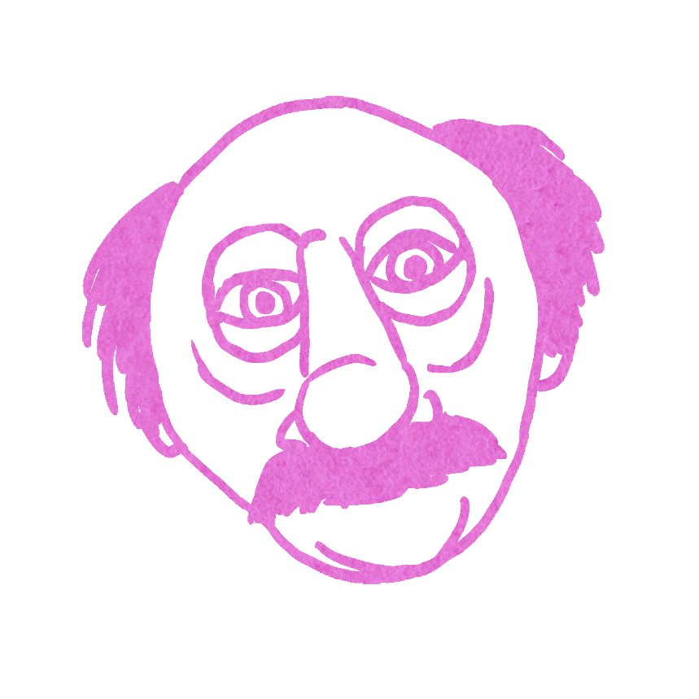
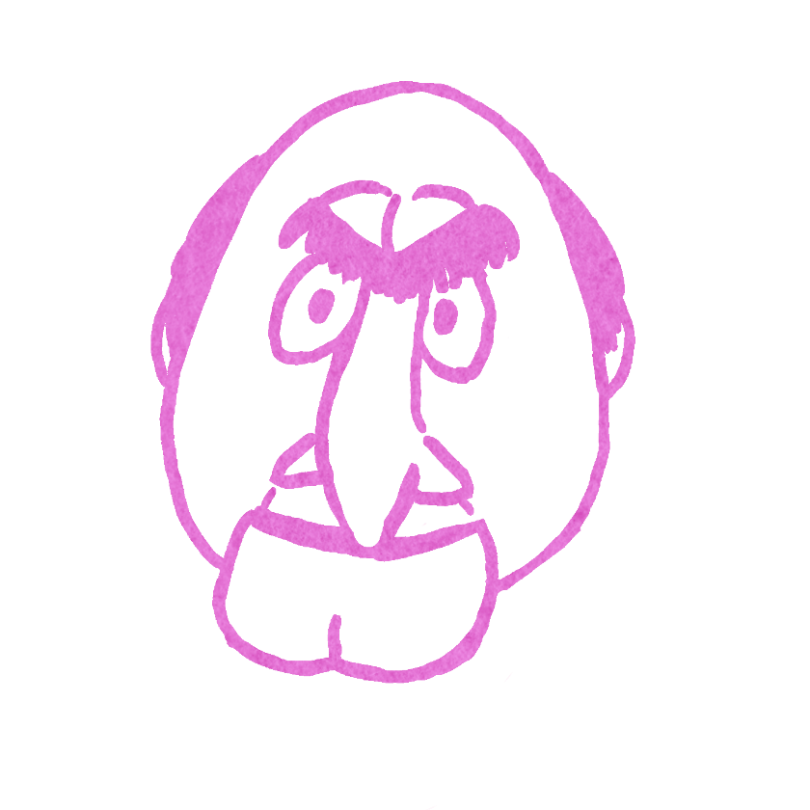

HOW TO RUN
Statler and Waldorf are twin Demons, who together choose one player to kill.
While setting up the game, before putting character tokens in the bag, remove one Minion token and ensure that both the Statler and Waldorf tokens are in the bag.
On the first night, wake Statler and show them Waldorf’s token and point at the corresponding player. Then show them any Minions and 3 bluffs as normal. Send Statler to sleep. Wake Waldorf and show them Statler’s token and point at the corresponding player. Then show them any Minions and 3 bluffs as normal. Send Waldorf to sleep. Statler and Waldorf do not have to receive the same 3 bluffs.
Each night except the first, wake Statler and Waldorf together. They both point at any player. When they agree and both point at the same player, put them both to sleep. The chosen player dies: put Statler and Waldorf's DIED TONIGHT reminder token by the chosen player's character token in the Grimoire and put a shroud on it.
At dawn, declare which player(s) died at night. (Do not say how they died.)
The good team can’t win until both Statler and Waldorf are dead.
EXAMPLES
One the first day Statler is executed and dies. On the second night, Statler and Waldorf still both wake together and each point at different players. The Storyteller gives each an exacerbated look until they both point at same player. That player dies.

WALDORF: “They aren’t half bad.”
STATLER: “Nope, they’re ALL bad!”

STATLER & WALDORF
DEMON(S)
STATLER: Each night*, wake with Waldorf, together choose one player: they die. [+ Waldorf, -1 Minion]
WALDORF: Each night*, wake with Statler, together
choose one player: they die. [+ Statler]

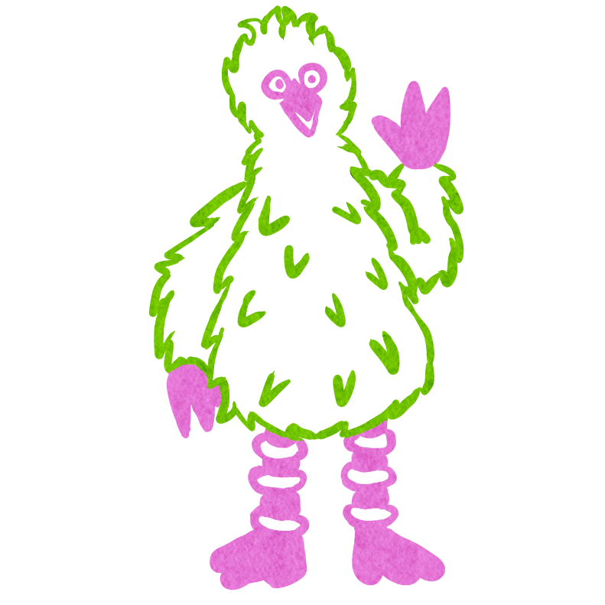

BIG BIRD
TRAVELLER
You are the tallest player.

“Show your true colours. Mine is yellow.”
HOW TO RUN
Traveller players may join the game at any time, and may leave the game at any time.
If they are evil, they learn who the Demon(s) are; they do not learn any additional evil characters or receive any bluffs.
Big Bird must be the tallest player.
If Big Bird isn’t the tallest player, whether accidentally or not, they are cheating. Remember it is important to address negative behaviour sooner rather than later. As Big Bird is a Traveller, they can be removed from the game if they continue to cause issues. It is up to Storyteller discretion to decide how lenient they wish to be.
EXAMPLES
Big Bird climbs on furniture and stretches up to be the tallest player. They are exiled like a normal traveller and decide to climb back down. They are no longer the tallest player and are not required to be.
Big Bird piggy backs on another player to be taller. That player puts Big Bird down, meaning they are no longer the tallest player. The storyteller pulls Big Bird for a private conversation and reminds them of the rules of the game. They continue to cheat and are removed from the game.

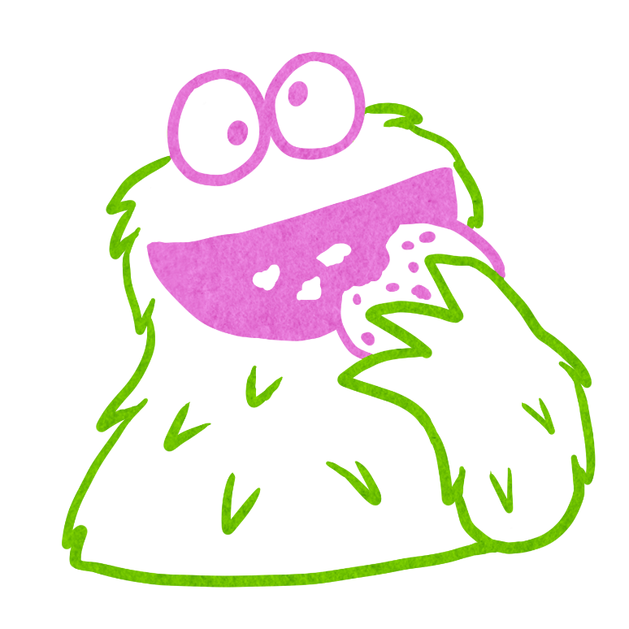

COOKIE MONSTER
TRAVELLER
All players must share their snacks with you.

“No cry because cookie is finished. Smile because cookie happened.”
HOW TO RUN
Traveller players may join the game at any time, and may leave the game at any time.
If they are evil, they learn who the Demon(s) are; they do not learn any additional evil characters or receive any bluffs.
All players must share their snacks with the Cookie Monster. It’s pretty self-explanatory.
EXAMPLES
Cookie Monster eats all the snacks other players brought.

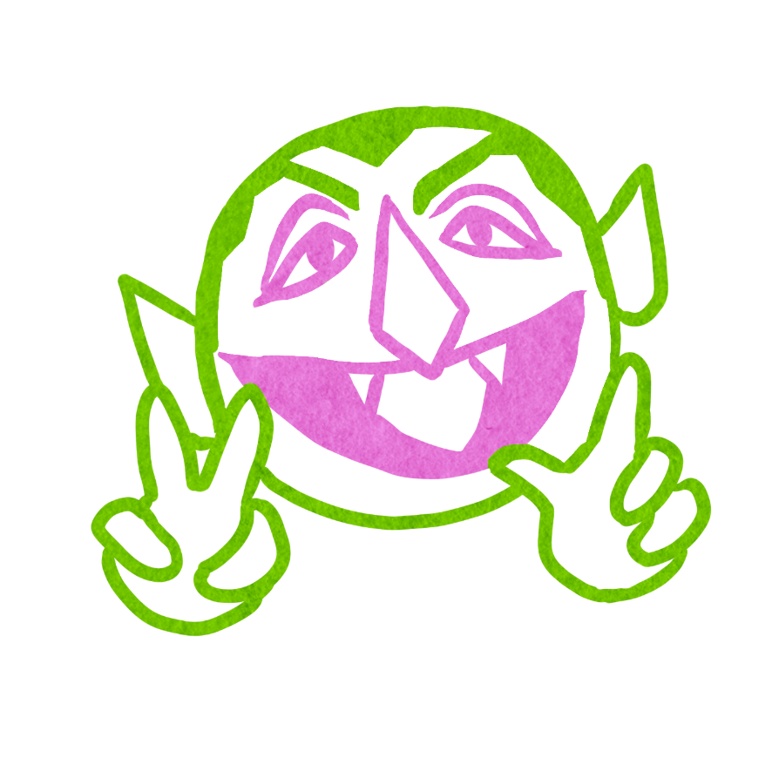

COUNT VON COUNT
TRAVELLER
You conduct and count each vote.

“One. AH AH AH. Two. AH AH AH.”
HOW TO RUN
Traveller players may join the game at any time, and may leave the game at any time.
If they are evil, they learn who the Demon(s) are; they do not learn any additional evil characters or receive any bluffs.
When a player is nominated and everyone is voting on whether or not to execute them Count Von Count takes the place of the storyteller to conduct the vote. They move their hand from the nominated player in a clockwise direction, counting votes when a player’s hand is up when Count Von Count’s hand reaches them.
The vote must still be conducted in line with the rules of the game.
EXAMPLES
A player is nominated. Count Von Count stands in the middle counting the vote. As they reach each raised hand, they announce the number votes followed by “AH AH AH.”. They announce whether or not there are enough votes for the nominated players to be on the block.

